IP INFORMATION DOCUMENT
Dated: 07/04/2025
Addressed to: Sahyadri College of Engineering & Management
Quotation Prepared by: Adv. Pranav Bhat
Contact Details: 9035685434
Email: an.astraea@gmail.com

QUTATION FOR IP:-
Months | Patent | TM | Copyright
0 - Seaching |  | 36*2,000= 72,000
1 - Filing | 9 * 34,350 = 3,09,150 | 26*17,000 = 4,42,000 | 5*18,000=90,000
6 - Examination | NA | 13*11,800=1,53,400 (assuming 50% marks are not obected) | NA
12 - Examination | 9*59,500=5,35,500 | 7*11,800=82,600 (assuming 50% of objected marks do not need hearing) | NA
18 -Examination | 9*50,000=4,50,000 |  | NA
24- Examination | 9*58,000=5,22,000 |  | NA
TOTAL | 18,00,000 | 6,78,000 | 90,000
Comment | 100% reimbursement from Startup Karnataka Scheme | This is considering mark in 1 class, and considering grant of marks without significant objections. Opposition is not considered.
Grand Total | 25,68,000/-

CHECKLIST AND TESTS FOR SELECTING A TRADEMARK
PLEASE REFER THIS TO COIN TRADEMARKS
Does it explain nature of business?
Word and Logo
Is it in the market/ has a goodwill?
Word and Logo
Is there a similar existing mark?
Logo
Logo
Yes
Yes
Yes
Yes
No
No
No
No
Is it an existing
dictionary word?

MADEUP WORDS ARE REGISTERED FAST AND COMMONLY KNOWN WORDS GO TILL HEARING

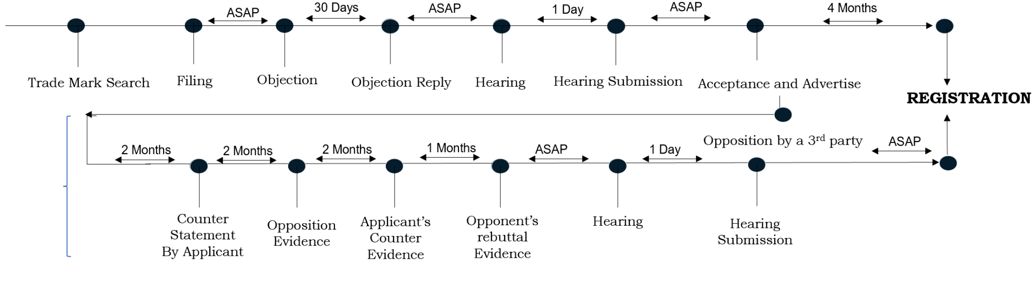
TRADEMARK CYCLE - EXEMPLARY SCENARIO:
___________________________________________________________________________________________________________
1. In case of requirement of expedited examination, relevant fee can be paid to speed up the process.
2. 3rd party Opposition can be filed by anyone.
3. Trademark search includes search on the Trademark portal provided by the IPATO.

FEE BREAKDOWN FOR IP:
Field | Patents cost Earlier |  | Patents cost Revised
Field | Govt and Misc | Prof Fee | Govt and Misc | Prof Fee
Drafting and Filing of patent with early publication | Rs. 5000 | Rs. 29,500 | Rs. 5000 | Rs. 19,500
Reply to First Examination  Report with RFE | Rs. 5000 | Rs. 16,000 | Rs. 5000 | Rs. 10,000
Total | Rs. 10,000 | Rs. 45,500 | Rs. 10,000 | Rs. 29,500
Field | Design and Copyright
Field | Govt and Misc | Prof Fee
Filing Design Application to issuance of certificate (As an Educational Institution) | Rs. 5,000 | Rs. 3,000
Filing Design Application to issuance of certificate (As an Individual) | Rs. 2,000 | Rs. 3,000
FilingCopyright Application to issuance of certificate (As an Educational Institution) | Rs. 2,500 | Rs. 2,500

ALTERATIONS MADE FROM LAST QUOTATION:
We’ve reduced the cost per patent by ₹16,000, saving ₹8,00,000 for 50 patents. With a new retainer fee of ₹40,000 per month (₹4,80,000 for 12 months), your organization gains a surplus benefit of ₹3,20,000. See the details below: -
S.No. | Description | Amount (₹) | Notes
1 | Cost Reduced Per Patent (from old quotation) | 16,000 | Savings per patent compared to previous quote
2 | Cumulative Cost Reduction (for 50 patents) | 8,00,000 | Total savings: 16,000 × 50 patents
3 | New Retainer Fee Per Month | 40,000 | New monthly charge for ongoing services
4 | Total Retainer Fee (for 12 months) | 4,80,000 | Calculated as: 40,000 × 12 months
5 | Surplus Benefit to Organization | 3,20,000 | Net savings: 8,00,000 - 4,80,000


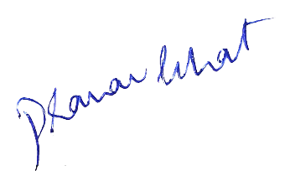
Should you have any questions or require further clarification, please feel free to contact us at the provided email or phone number. Thank you for considering our services. We look forward to assisting you with your intellectual property needs.

Best Regards,
Adv. Pranav Bhat, Chief IP Strategist
Lextria Research, Manipal

